|  |  |
| --- | --- |
| ITB logo portrait B&W | INSTITUTE OF TECHNOLOGY BLANCHARDSTOWN  A Taster of Computing  [[VERSION – Unity 2D – C# language]] |

Gravity Guy 3D (2014) - a little computer game... now in 3D

Part 1a – setting up a 3D game from scratch

CONTENTS

1 Create a new project, with some useful Unity-provided packages 2

2 Create basic 3D scene with light and terrain 3

3 Add a 3D character to your scene 5

4 Add a sky-box to the camera and some ‘dirt’ to your terrain 6

5 Fix the animations on the handyman 8

# Create a new project, with some useful Unity-provided packages

## Basic Unity 3D game components

Unity 3D games generally have:

* Terrains
  + landscanpe ‘meshes’ respresenting flat or hilly or stepped ‘ground’ on which the game action takes places
  + terrain ‘textures’ – images ‘pained’ onto the terrains, to look like grass, stone, glass etc.
* lights
  + direction lights, like the sun
  + spot lights
  + etc.
* a 3D animated character, with a controller script
  + for now just use the handyman’ provided in the ‘CharacterController’ standard assets package
* camera ‘sky boxes’
  + images for what we see ‘in the distance’, such as stars, clouds etc.
  + to give a more realistic 3D ‘feel’ when moving around the scene

## Create new project with useful Standard Assets

Create a new project as follows:

* Choose menu: File | New Project …
* From the Project Wizard dialog:
  + Choose the location of your new project, the **Project Directory** (click Set…/Browse… and create a folder in the desired location)
  + TICK the following packages to import:
    - CharacterController
    - Skyboxes
    - TerrainAssets
  + Esnure the “Set up defaults” is “3D”
* Then click the **Create Project** button:

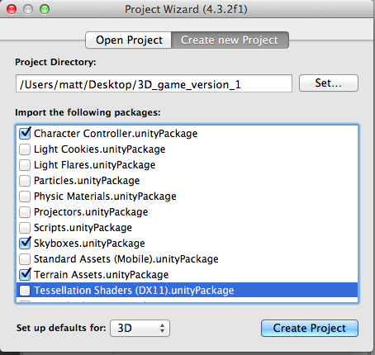

# Create basic 3D scene with light and terrain

## Save new scene as ‘scene1’

Create a folder “Scenes”, and save the current, empty, scene into your Scenes folder naming it “scene1”.

## Add a Directional Light to your Scene

Add a light as follows:

* In the **Inspector** from the Create dropdown menu, choose **Directional Light**

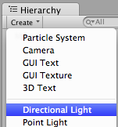

## Create a new Terrain

Add a terrain as follows:

* In the **Inspector** from the Create dropdown menu, choose **Terrain**

## Size the Terrain resolution (size) to 100 x 100

Resize the terrain to 100 x 100:

* Select the terrain in the **Hierarchy**
* In the **Inspector**, for the Terrain (Script) component, click the ‘gear’ icon

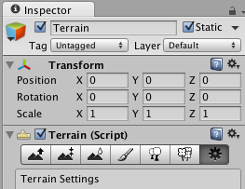

* In the **Resolution** section of the Terrain Settings, set the Width and Length both to 100 unity units:

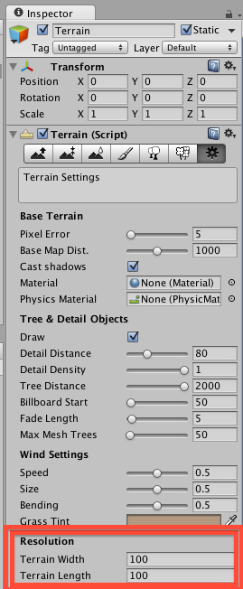

## Size the Terrain position at (-50, 0, -50) so its centre is (0,0,0)

Set the terrain position (one of its corners) to (-50, 0, -50):

* Select the terrain in the **Hierarchy**
* In the **Inspector** for the **Transform** component, set the **Position** to (-50, 0, -50)
  + This ensures the CENTRE the terrain is at (0, 0, 0)
  + The general rule is to position to terrain to:
    - (-width/2, 0, -length/2)
    - to ensure its centre is always (0,0,0)
  + this allows you to ‘grow’ the terrain later in the design process if you wish, but your scene contents are always based around (0,0,0) so you won’t need to reposition any objects, or change any coordinate positions in your code if the terrain is resized.

# Add a 3D character to your scene

## Add the ‘handyman’ 3D character to your scene

Do the following:

* In your **Project panel** locate the **3rd Person Controller** prefab

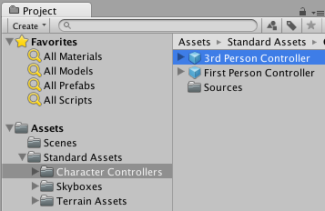

* Drag a copy into the **Scene**
* Set the **Position** of your character to (0, 1, 0)
  + It needs to have a Y-coordinate greater than zero, because the character’s centre would be stuck in the ground if it was position at (0,0,0) – try it !

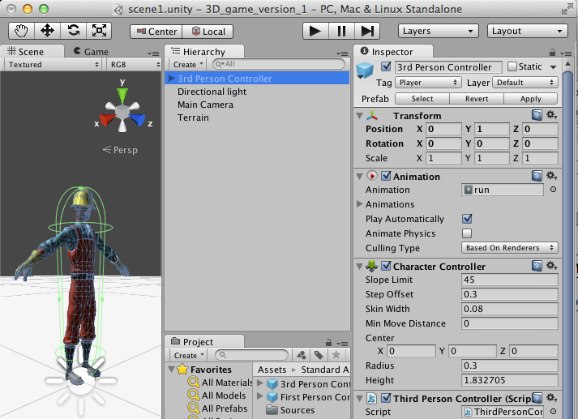

## Playtest your game

Run your game

You have a character that can move around the terrain

But …. The ground is all white, and there above the horizon is plain, camera default ‘blue’ – so we need to add some ‘reality’ to get a good feeling of movement and environment ….

# Add a sky-box to the camera and some ‘dirt’ to your terrain

## Add a skybox to the Main Camera

Do the following:

* Select the **Main Camera** in the **Hierarchy**
* In the **Inspector** add component: Rendering | Skybox
* For the Skybox component, click the small ‘target’ to the right of the box for Custom Skybox

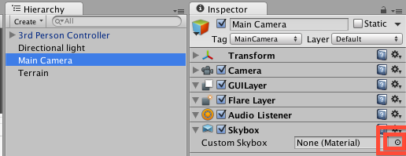

* Select a skybox from the popup window, e.g. Overcast1 Skybox
* Select he **Game panel**
  + you should see the skybox clouds above the horizon …

## Add some ‘dirt’ texture to your terrain

Do the following:

* Select the **Terrain** in the **Hierarchy**
* In the **Inspector** for the Terrain (Script) component, select the Paint Texture (paintbrush) icon

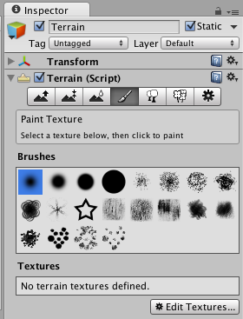

* Click button “Edit Textures” and choose “Add Texture …”
* In the “Add Terrain Texture” popup window, click the “Select” button for Texture (on the left)

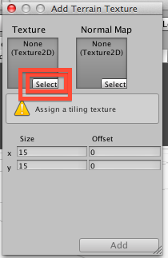

* + Double click a nice texture
    - I like “good dirt” as the default texture for the whole terrain
  + Click button Add

## Playtest your game

Run your game. Now you should have much better feeling of solid ground and movement and distance …

Now to fix the animations on your character …

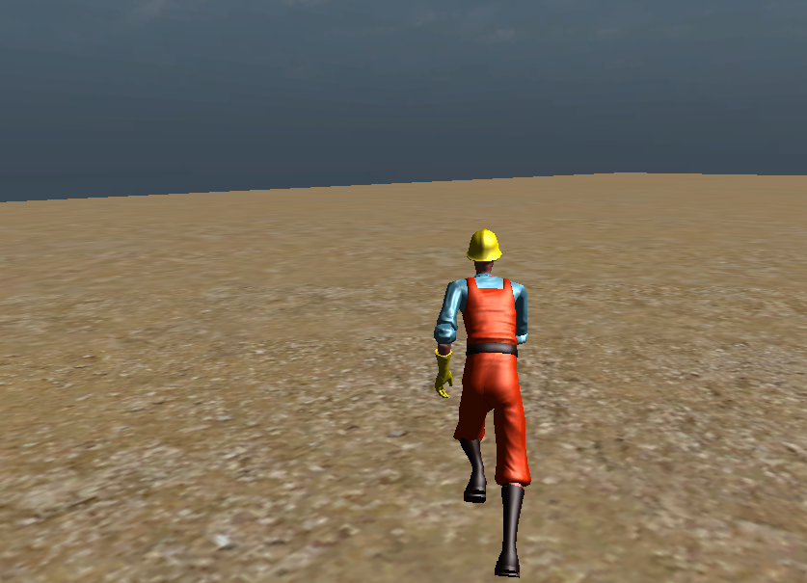

# Fix the animations on the handyman

## Assign the missing animations – METHOD 1 - if few animations in your project

(if there are only a few animations in your project, this is the fastest way to assign these animations…)

Do the following:

* Select the **3rd Person Controller** in the **Hierarchy**
* In the **Inspector** click the ‘target’ circle to the right of the **Idle Animation** slot
* Double-click the **“idle”** animaton from the popup window
* Do the same for run, walk, jump

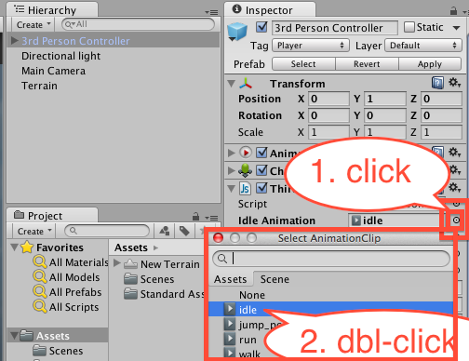

## Assign the missing animations – METHOD 2 – step-by-step

Do the following:

* Select the **3rd Person Controller** in the **Hierarchy**
* In the **Project panel** select folder: **Assets |**

